Meshaal Mouawad
Mississippi State University, Electrical and Computer Engineering Department,
This is a summary report of my research assignments I was given by my advisor during my PhD program
Summary Report: week 17
For Research Assignments of my PhD

July 10, 2021
Voronoi Diagram Project

- Environmental Exploration: Construction of TWO kinds of Voronoi Diagram maps: Voronoi Diagram, and Generalized Voronoi Diagram (GVD) as follows. We do not need to implement and program VD, and GVD. There are some MTALB functions/commands for VD available. GVD might be available in MTALB as well, Or we may find online with MTALB file exchange, github, Sci-hub (https://en.wikipedia.org/wiki/Sci-Hub), or other resources.

Start Generating VD from the MATLAB code:
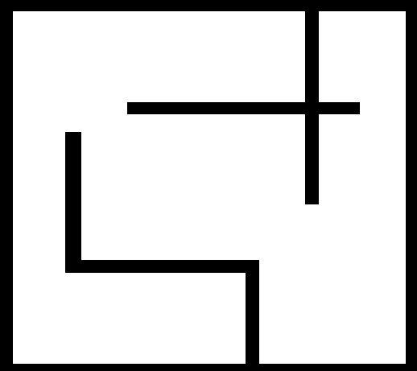
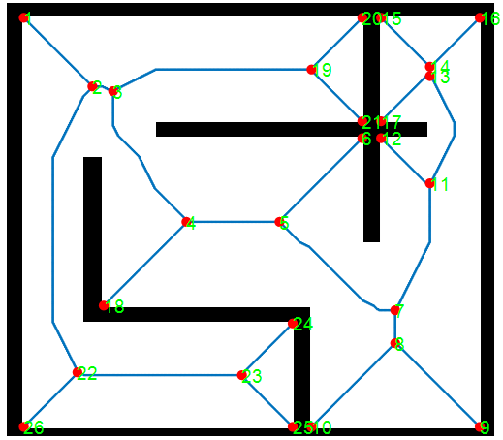
Figure. 2 the result from the matlab code

- Multi-goal path planning: Once the construction of Voronoi Diagram (GVD) maps is accomplished, some algorithms for TSP (Travelling salesman problem) is applied to connect some goals/waypoints that we need to explore, rescue, and reach. Running your TSP algorithm to connect some points such as green stars:
I used another Python code for TSP and successfully run it! Gorubi Module was used for optimization. The output for the optimal path is:

[(0, 1), (1, 2), (2, 3), (3, 4), (4, 5), (5, 0)]

Time taken by MTZ formulation = 1.2135167121887207

The solution visualization is:
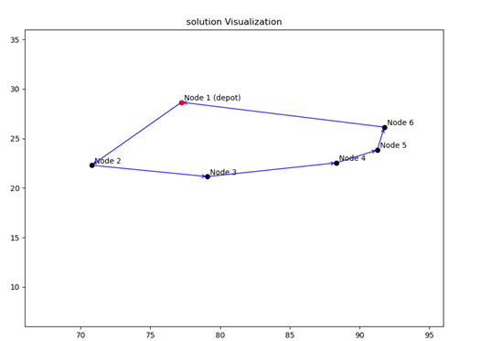

- Local navigator using DWA (Dynamic Window Approach): ) method to walk a mobile robot from starting point to goal along the edges of built GVD. DWA to navigate the robot to connect multiple goals depicted by the green stars.

I am waiting the code you told me to send it to me

After that, the next step will be the Mapping

Conclusion

VD
Generate VD
TSP:
to connect multiple points, and minimize traveling distant.

DWA:
Path planning and local navigation. To walk the robot from start point to the goal along the edge of GVD.

Mapping:

